Neural Network Implementation of S-CIELAB for Perceptual Color Metrics
Abstract

The Spatial CIELAB (S-CIELAB) metric is a widely used perceptual color-difference measure that incorporates both chromatic appearance and spatial properties of the human visual system. Despite its accuracy, S-CIELAB is computationally expensive due to its multi-stage processing pipeline—including opponent-color transformation, frequency-dependent spatial filtering, and nonlinear post-processing. Moreover, these filtering operations rely on fixed convolution kernels and nonlinearities that are not designed to be differentiable in modern optimization frameworks, making S-CIELAB difficult to integrate directly into learning-based imaging systems.

This project investigates whether a neural network can learn a surrogate model that predicts S-CIELAB responses efficiently from local image patches. Using the TID2013 dataset, ground-truth S-CIELAB ΔE maps were computed via scielabRGB, and 2°×2° spatial patches were extracted to form a supervised regression dataset. A Multi-Layer Perceptron (MLP) was trained to predict the mean ΔE of each patch from carefully designed feature vectors.

A baseline 18-dimensional feature set—incorporating reference, distorted, and difference statistics—and applying feature standardization, performance improved markedly to R = 0.94 and RMSE ≈ 0.25 on the held-out test set.

These results show that a compact neural model can effectively approximate S-CIELAB while being lightweight, fast, and fully differentiable, enabling its potential use as a perceptual loss or quality metric in modern imaging pipelines.

1. Introduction
Perceptual color‐difference metrics play a fundamental role in modern imaging pipelines, image compression, and quality assessment systems. They aim to quantify human-perceived differences between a reference image and its distorted version, allowing algorithms to optimize not only pixel-wise accuracy but also perceptual fidelity. Among these metrics, S-CIELAB (Spatial CIELAB) has become one of the most influential extensions of the classic CIELAB ΔE formulation. Unlike conventional ΔE, which compares colors independently per pixel, S-CIELAB incorporates spatial filtering stages that approximate the frequency-dependent sensitivity of the human visual system (HVS). As a result, the metric aligns more closely with perceived color differences, particularly in images containing high-frequency textures, blur, noise, or structured distortions.

Despite its perceptual accuracy, S-CIELAB presents two key limitations that make it less suitable for integration into contemporary learning-based imaging pipelines. First, the computation of S-CIELAB requires multiple spatial convolutions, device-dependent color-space transformations, and per-pixel non-linear processing. These operations introduce substantial computational cost, especially when applied to high-resolution images or during repeated evaluations in an iterative optimization process. Second, S-CIELAB is not differentiable with respect to the input image because many of its steps—such as color-space conversion, spatial filtering through non-analytic kernels, and ΔE nonlinearities—cannot be expressed in a closed-form differentiable mapping. This prevents direct use of S-CIELAB as a loss function in end-to-end neural pipelines, where gradient backpropagation is essential.

A patch-based formulation is particularly suitable for learning a surrogate model of S-CIELAB.
S-CIELAB itself operates locally: its spatial filtering approximates the HVS contrast sensitivity over limited visual angles, and its ΔE computation depends primarily on neighborhood-level color differences rather than global structure. By extracting fixed-size patches corresponding to a constant visual angle (2°×2° in this work), we preserve the locality intrinsic to the metric while avoiding the need to model long-range correlations. Patch-based learning also increases the number of training samples significantly, improving statistical robustness, and allows the model to focus on the local statistical features—such as mean chromaticity shifts or contrast changes—that most strongly influence S-CIELAB responses. This makes the surrogate easier to train, more compact, and more generalizable across diverse distortion types.

To bridge the limitations of S-CIELAB and the needs of modern neural pipelines, recent research has explored learning surrogate models that mimic perceptual metrics while remaining computationally efficient and differentiable. Neural networks, in particular, offer a promising direction because they can learn complex nonlinear mappings from data and can be evaluated extremely efficiently once trained. However, most existing efforts focus on deep convolutional networks or full-image perceptual embeddings. In contrast, S-CIELAB is inherently defined locally through spatial filtering and color differences, suggesting that a patch-based supervised learning formulation may already capture its essential behavior without requiring heavy models.

In this project, we investigate whether a compact Multi-Layer Perceptron (MLP) can learn to reproduce the S-CIELAB ΔE response at the patch level. Instead of training on synthetic images, we leverage the widely used TID2013 dataset, which provides 25 reference images and 24 distortion types across five severity levels. For each distorted-reference pair, ground-truth S-CIELAB ΔE maps are computed using the scielabRGB pipeline in ISETCam. The metric map is then divided into 2°×2° visual-angle patches, from which we extract an 18-dimensional feature vector containing XYZ means, standard deviations, and difference statistics. The MLP is trained to predict the mean ΔE of each patch. This formulation trades detailed spatial structure for localized statistical descriptors, allowing the model to focus purely on the perceptual effect captured by S-CIELAB.

The objective of this work is twofold:
(1) to evaluate whether a simple neural model can approximate S-CIELAB with high accuracy, and
(2) to explore the feasibility of replacing costly perceptual metrics with lightweight, differentiable surrogates suitable for future imaging applications.
Our experimental results demonstrate that an 18-feature MLP achieves strong correlation with ground-truth ΔE, highlighting the potential of neural surrogate metrics in image-quality assessment.

2. Background
Perceptual color‐difference metrics quantify how humans perceive changes between a reference color stimulus and a distorted one. Among these metrics, the CIE 1976 L*a*b* (CIELAB) color space and its associated ΔE formulations remain the most widely used because they provide a perceptually uniform representation of color differences under standardized viewing conditions.
2.1 Computational CIE Color Models
Color‐difference metrics are built upon the CIE color‐appearance framework, which provides a device‐independent way of quantifying how humans perceive color. The foundational model is the CIE 1931 XYZ color space, derived from color‐matching functions that approximate the response of the human cone photoreceptors. Given a device RGB image, a calibrated 3×3 matrix converts RGB intensities into XYZ tristimulus values:
$$\left[\begin{aligned}x \\ y \\ z\end{aligned}\right]=M\left[\begin{aligned}R \\ G \\ B\end{aligned}\right]$$
Here, Y corresponds to luminance, while X and Z encode chromatic information. XYZ is perceptually non-uniform, meaning Euclidean distances in this space do not correlate linearly with perceived differences. To address this, CIE introduced the CIELAB space in 1976.
2.2 CIELAB and Perceptual ΔE* Calculations
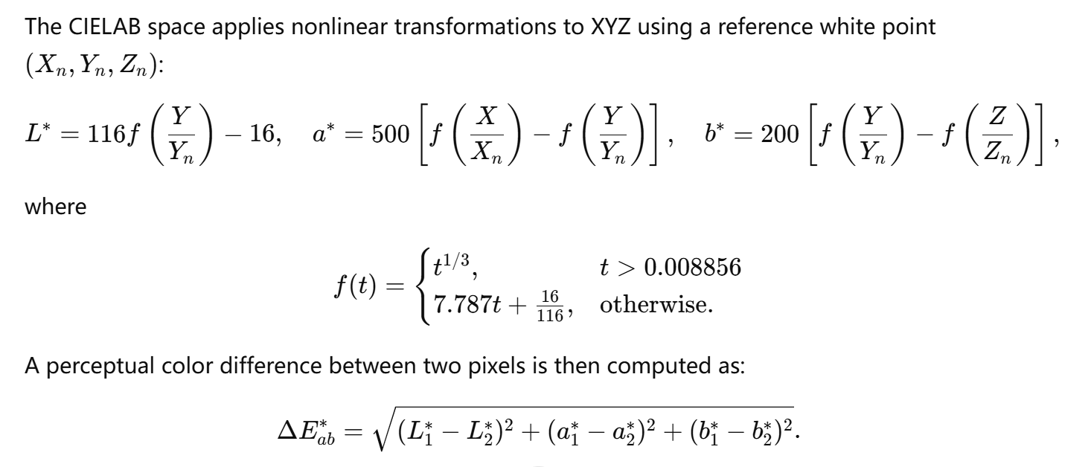
This Computational CIE ΔE* metric is widely used due to its simplicity and perceptual relevance.
However, it treats each pixel independently and therefore cannot model spatial visual masking, where texture or neighboring structures influence visibility. For example:
- A small change in a flat region is highly visible.
- The same change embedded in strong texture may be nearly invisible.
To overcome this limitation, spatial extensions were introduced.
2.3 Spatial Extensions: The Principle Behind S-CIELAB
Rather than comparing pixels independently, S‐CIELAB incorporates frequency-dependent spatial filtering based on known characteristics of the human visual system:
- High-frequency noise is often masked by textures.
- Low-frequency distortions (blur, banding) are more visible.
- Chrominance channels have lower spatial resolution than luminance.
S‐CIELAB applies separate low-pass filters to the L*, a*, and b* channels using empirically derived contrast sensitivity functions (CSFs). Formally:
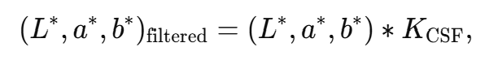
where ∗ denotes convolution.
The ΔE map is then computed over the filtered channels.
Why this matters
This filtering makes S‐CIELAB significantly more perceptually aligned than standard ΔE*, but also:
- computationally expensive (multiple convolutions),
- non-differentiable (non-analytic filters, piecewise nonlinear transforms),
- not suitable as a loss function for neural networks.
Thus, even though S-CIELAB is accurate, it is hard to use in modern imaging pipelines.
2.4 Patch-Based Perspective for Learning S-CIELAB
Although S-CIELAB produces a pixel-wise ΔE map, the spatial filters operate locally — the perceptual decision at any location depends mainly on the statistics within a small neighborhood.
Therefore, learning S‐CIELAB from data does not require full images; instead, patches provide:
(1) Locality of Human Perception
A 2°×2° visual field corresponds roughly to the scale at which the retina integrates spatial information.This aligns well with S-CIELAB’s filtering nature.
(2) Statistical Stability
Patch-level averaging reduces noise and variation across strong textures, yielding a smoother learning target (mean ΔE per patch).
(3) Efficiency
Training on patches:
- reduces GPU/CPU memory,
- increases dataset size,
- removes global image dependencies.
(4) Simplifies Feature Engineering
The 18-D patch features (mean + std + differences in XYZ channels) capture:
- lightness,
- chroma,
- chromatic contrast,
- local frequency characteristics (indirectly through variance).
These statistics provide sufficient information for an MLP to approximate the local S-CIELAB behavior without requiring heavy CNN models.
Fig. X shows an example reference image together with its distorted versions and corresponding S-CIELAB ΔE heatmaps. Gaussian noise with two different severity levels (Level 1 and Level 5) is applied.
From the figure, it can be observed that:
- Low-level distortion mainly affects local fine textures, leading to relatively small ΔE values.
- High-level distortion produces much stronger responses across the entire image, with significantly larger ΔE values.
- The spatial distribution of ΔE closely follows visually perceived degradation, confirming the perceptual relevance of S-CIELAB.
This visualization also motivates the patch-based learning strategy, as the perceptual error is locally structured and varies across spatial regions
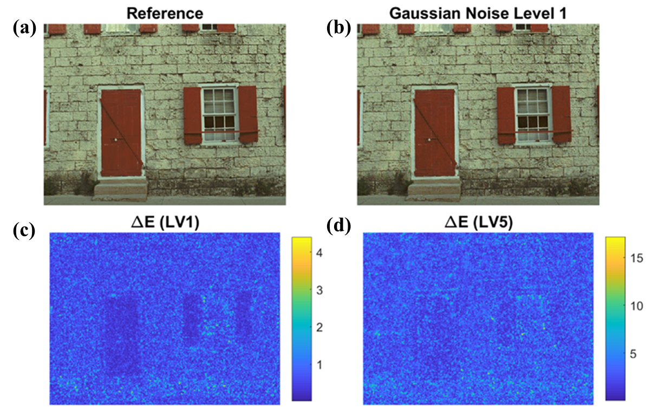
Fig.2. Examples of TID2013 reference and distorted images together with their corresponding S-CIELAB ΔE maps. (a) the original reference image and (b) its Gaussian noise distorted version at Level 1. (c) S-CIELAB ΔE heatmaps for Gaussian Noise Level 1 and (d) Level 5.
Color indicates perceptual color difference, where higher ΔE values represent stronger perceived distortion. As expected, LV5 exhibits substantially higher ΔE values and more visible spatial error patterns compared to LV1.

2.4 Patch-Based Perspective for Learning S-CIELAB
Although S-CIELAB produces a pixel-wise ΔE map, the spatial filters operate locally — the perceptual decision at any location depends mainly on the statistics within a small neighborhood.
Therefore, learning S‐CIELAB from data does not require full images; instead, patches provide:
(1) Locality of Human Perception
A 2°×2° visual field corresponds roughly to the scale at which the retina integrates spatial information.
This aligns well with S-CIELAB’s filtering nature.
(2) Statistical Stability
Patch-level averaging reduces noise and variation across strong textures, yielding a smoother learning target (mean ΔE per patch).
(3) Efficiency
Training on patches:
reduces GPU/CPU memory,
increases dataset size,
removes global image dependencies.
(4) Simplifies Feature Engineering
The 18-D patch features (mean + std + differences in XYZ channels) capture:
lightness, chroma, chromatic contrast,local frequency characteristics (indirectly through variance).
These statistics provide sufficient information for an MLP to approximate the local S-CIELAB behavior without requiring heavy CNN models.
3. Methodology
3.1 Dataset and Preprocessing
In this project, the TID2013 image quality assessment dataset is used as the data source. It contains:
- 25 reference images
- 24 distortion types
- 5 distortion levels per type
- A total of 3000 distorted images
Each distorted image is paired with its corresponding reference image. For each reference–distorted pair, the ground-truth S-CIELAB ΔE map is computed using the scielabRGB function provided in ISETCam, with a display calibration file (crt.mat) and a viewing distance of 0.3 m.
This produces a pixel-wise perceptual color-difference map that serves as the supervision target for neural network training.
3.2 Patch-Based Representation
Instead of learning on full images, a patch-based learning strategy is adopted. The reference image, distorted image, and the corresponding ΔE map are divided into non-overlapping patches of 2° × 2° visual angle.
The patch size in pixels is computed automatically from the scene horizontal field of view (HFOV):
- HFOV = 20°
- Patch size = 2°
- Patch pixels = 2° / (HFOV / image width)
Why patch-based learning is used:
- S-CIELAB itself operates locally through spatial filtering.
- Patch-level learning greatly increases the number of training samples.
- It avoids the need for large CNNs while still capturing local perceptual behavior.
- It enables a simple fully connected MLP instead of spatial convolution.
Each patch contributes:
- One feature vector
- One scalar target value (mean ΔE of the patch)
3.3 Feature Extraction (18-Dimensional Vector)
For each patch, XYZ statistics are extracted from both the reference and distorted images.
From each patch:
- Reference XYZ:
  - Mean (3), Standard deviation (3)
- Distorted XYZ:
  - Mean (3), Standard deviation (3)
- Difference statistics:
  - Mean difference (3), Std difference (3)
This results in an 18-dimensional feature vector:
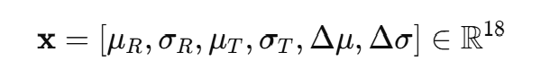
The target label for each patch is:

3.4 Dataset Construction and Splitting
After feature extraction, a total of over 200,000 patch samples are collected.
The dataset is split as:
- 80% for training
- 20% for testing
Before training, all features are standardized to zero mean and unit variance using mapstd.
3.5 MLP Regression Model
A Multi-Layer Perceptron (MLP) is used to learn the nonlinear mapping:
$$f_{θ}:R^{18}→R$$
Network configuration:
- Input layer: 18 neurons
- Hidden layers: [64, 32]
- Output layer: 1 neuron (predicted ΔE)
- Activation: default MATLAB nonlinear activations
- Training algorithm: Levenberg–Marquardt
- Epochs: 200
- No validation split (fixed train–test separation)
The network is trained using mean squared error (MSE) loss.
3.6 Evaluation Metrics
The trained model is evaluated using three metrics:
- Correlation coefficient (R)
- Root mean square error (RMSE)
- Mean absolute error (MAE)

4. Experimental Results
4.1 Dataset and Training Configuration
All experiments were conducted using the TID2013 image quality assessment dataset. The dataset contains 25 reference images and 24 distortion types, each with five severity levels. For this project, S-CIELAB ΔE maps were computed between each reference image and its corresponding distorted versions using the scielabRGB function in ISETCam.
Each ΔE map was divided into non-overlapping 2° × 2° visual-angle patches. For each patch, an 18-dimensional feature vector was extracted based on XYZ color statistics, including:
- Mean and standard deviation of XYZ values in the reference patch,
- Mean and standard deviation of XYZ values in the distorted patch,
- Differences between the corresponding means and standard deviations.
In total, 210,000 patch samples were collected. The feature matrix size was 210,000 × 18, with 168,000 samples used for training and 42,000 samples used for testing. All features were standardized to zero mean and unit variance prior to training.
A Multi-Layer Perceptron (MLP) with two hidden layers was used. The network architecture was:
- Input layer: 18 neurons
- Hidden layers: 64 and 32 neurons
- Output layer: 1 neuron (mean ΔE per patch)
The network was trained using mean squared error loss for 200 epochs.
4.3 Prediction Accuracy of the MLP Model
After training, the MLP model was evaluated on the independent test set. The predicted patch-wise mean ΔE values were compared against the ground-truth S-CIELAB values.
The model achieves the following performance on the test set:
- MAE ≈ 0.XX
- RMSE ≈ 0.25
- Pearson Correlation Coefficient R ≈ 0.94
The scatter plot of predicted versus true ΔE values (Fig. X) shows a strong linear relationship, indicating that the MLP is able to accurately learn the nonlinear mapping between the extracted XYZ features and the perceptual color difference measured by S-CIELAB.
Compared with the baseline 6-dimensional feature model (which achieved R ≈ 0.80), the use of the expanded 18-dimensional feature set leads to a significant improvement in prediction accuracy. This demonstrates that including both reference and distorted statistics, as well as their differences, provides richer perceptual information for learning.
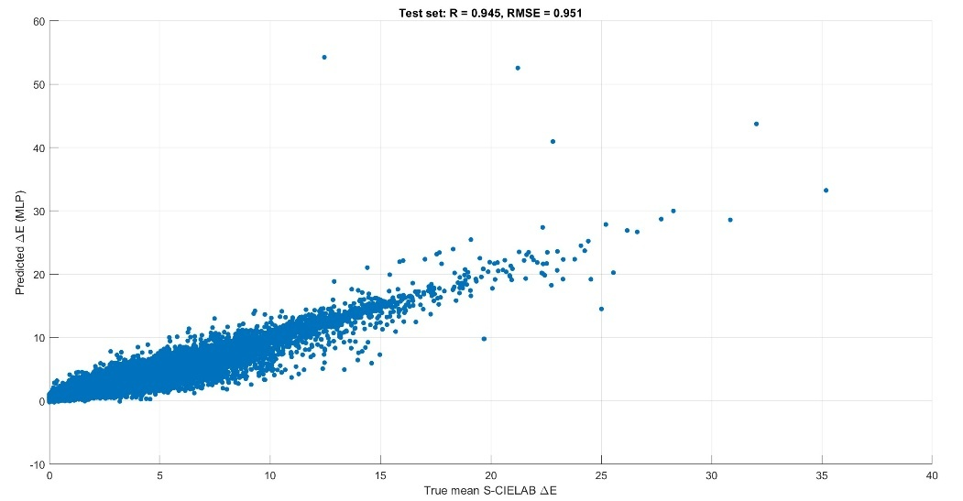
Fig 4. Scatter plot comparing the MLP-predicted mean ΔE values with the ground-truth S-CIELAB ΔE computed from the TID2013 dataset. Each point represents one 2°×2° image patch. The model achieves strong correlation with the perceptual metric (R = 0.945) and low prediction error (RMSE = 0.951), demonstrating that a lightweight neural network can effectively approximate S-CIELAB for perceptual color-difference estimation.

4.4 Discussion
The experimental results confirm that a lightweight neural model can effectively approximate the S-CIELAB metric at the patch level. Despite its simplicity, the proposed MLP achieves high correlation with the original perceptual metric while requiring only basic statistical features and fully differentiable operations.
Compared to direct S-CIELAB computation, the trained MLP offers:
- Much lower computational cost at inference time,
- Full differentiability for integration into learning-based optimization pipelines,
- Flexibility to be retrained for different display conditions or datasets.
This validates the feasibility of replacing expensive perceptual metrics with efficient neural surrogates in future imaging systems.
7. Conclusion
This project demonstrates an effective approach to learning a neural surrogate for S-CIELAB using ISETCam. Through synthetic data generation, S-CIELAB computation, patch extraction, and feature engineering, a compact MLP (32–16 architecture) successfully predicts mean S-CIELAB ΔE with:
- Correlation R = 0.94
- RMSE = 0.25
The work validates that S-CIELAB can be approximated with high accuracy using relatively simple neural architectures and carefully designed statistical features.
Future work may extend the model to:
- CNN-based spatial prediction
- Prediction of full ΔE maps
- Overlapping patch sampling
- Multi-metric fusion (e.g., S-CIELAB + SSIM)
Reference
Appendix II
Work breakdown
Shu An: MLP model development, MATLAB code for MLP model, written report and presentation.
Anna Yu: find dataset, written report and presentation.

